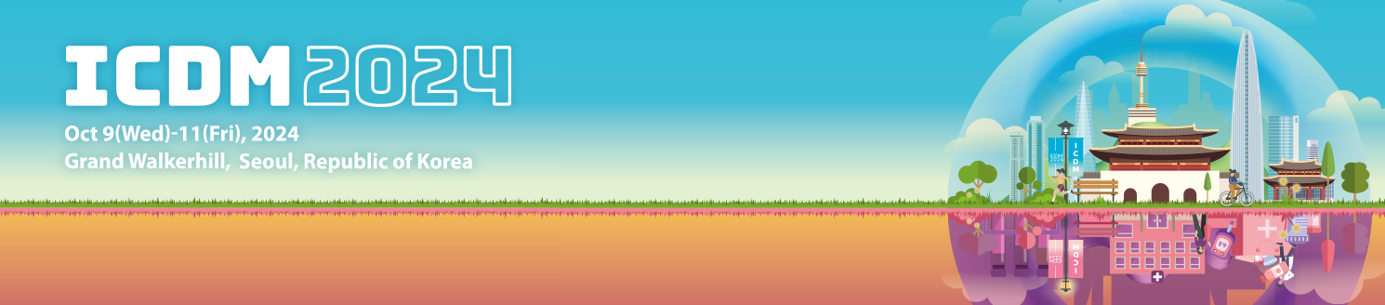
Request for Cancellation of 14th ICDM Registration

※ Please fill out the form and send it to the congress secretariat at icdm@diabetes.or.kr.

I. Personal Information
ID |  | Membership | □ Member □ Non-member
Name |  | Profession
Organization |  | Date of Birth | (i.e. 1980-Nov-16)
Phone |  | E-mail
Credit Card No. |  | Credit Card Vendor

II. Cancellation of Registration

Early registration
(~2 September 2024)
 | Domestic |  | International
 | Member | Non-Member | International
Full registration  (Regular rate) | [ ] USD 280 | [ ] USD 350 | [ ] USD 280
Full registration  (Reduced rate) | [ ] USD 180 | [ ] USD 230 | [ ] USD 180
One-day registration  (Regular rate) | [ ] USD 170 | [ ] USD 210 | [ ] USD 170
One-day registration  (Reduced rate) | [ ] USD 110 | [ ] USD 140 | [ ] USD 110
Low-income countries | [ ] USD 150
Gala Dinner | [ ] USD 55  Cancelling only for gala dinner is not possible.  If you wish to cancel the dinner, please cancel your  entire registration and re-submit your payment.

NOTE
- Cancellation of registration is only acceptable in written form BEFORE the deadline of registration.

By 2 September 2024 | 100% refund
From 3 September 2024 | No refund

I hereby request the cancellation of 14th ICDM registration.

YYYY/MM/DD Name (Signature)

